**Project Design Phase**

**Solution Architecture**

|  |  |
| --- | --- |
| Date | 25 june 2025 |
| Team ID | LTVIP2025TMID45798 |
| Project Name | Smart Sorting: Transfer Learning for Identifying Rotten Fruits and Vegetables |
| Maximum Marks | 4 Marks |

**Solution Architecture:**

Solution architecture in NutriGaze bridges the gap between the problem of manual freshness inspection and a deep learning-based web solution. Its goals for NutriGaze are to:

* Find the best technology stack to automate the detection of healthy or rotten fruits and vegetables using image classification.
* Describe the structure, characteristics, behavior, and data flow of the NutriGaze system for clear stakeholder understanding.
* Define features, development phases, and solution requirements aligned with food freshness detection.
* Provide a clear architecture and data handling specification for managing the AI model, Flask backend, and frontend integration.

**Example - Solution Architecture Diagram:**

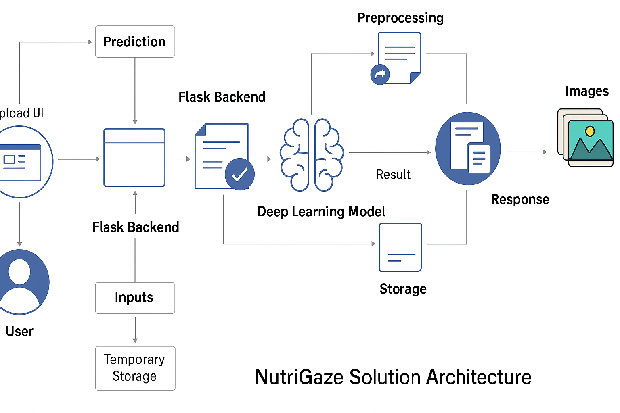

1. User Interface (Frontend):
   * Built with HTML, CSS, Jinja, JavaScript for a clean upload interface and result display.
   * Allows users to upload images of fruits/vegetables for classification.
2. Flask Backend:
   * Handles routing, image preprocessing, and communication with the ML model.
   * Stores uploaded images temporarily for processing.
3. Preprocessing Module:
   * Resizes, normalizes, and prepares the uploaded image for model prediction.
   * Uses TensorFlow/Keras preprocessing utilities.
4. Deep Learning Model (VGG16 with Fine-Tuning):
   * Loads the trained model to classify images into healthy or rotten classes across 28 categories.
   * Returns the predicted class label and associated confidence.
5. Response Layer:
   * Sends back the prediction result and displays it with the uploaded image.
   * Allows users to visually verify the result for trust and transparency.
6. Storage (Static Uploads Folder):
   * Manages temporary storage of user-uploaded images during the prediction process.